**Report**

Name**:** Mohammad Aslam Khorami, Group: IT-2401

**Part 1 – Creating Basic HTML Structure**

**Task:** Create a web page with basic HTML structure including title, meta description, and author information.

Input:

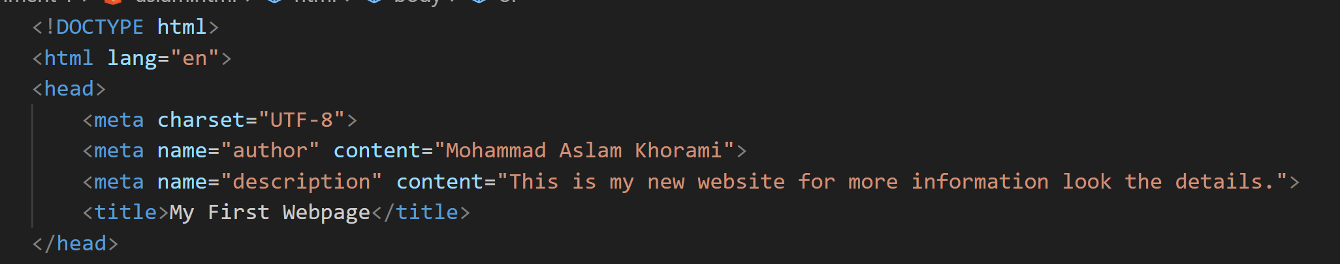

Output:

**Part 2 – Adding Personal Information**

**Task:** Add personal details such as name, course, and “About Me” section.

Input:

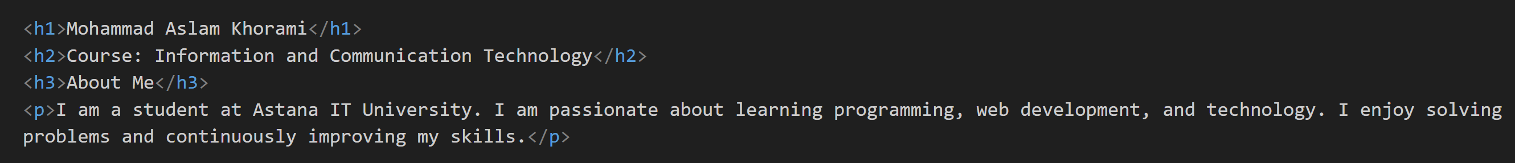

Output:

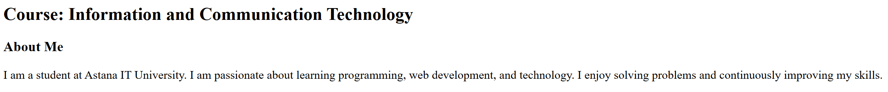

**Part 3 – Listing Hobbies**

**Task:** Create an ordered list (OL) of hobbies.

Input:

Output:

**Part 4 – Favorite Websites**

**Task:** Add an unordered list (UL) with links to favorite websites.

Input:

Output:

**Part 5 – Inserting an Image**

**Task:** Insert a personal photo using the <img> tag.

Input:

Output:

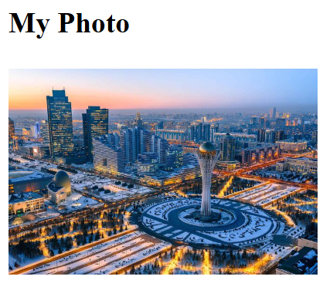

**Part 6 – Adding Button**

**Task:** Add a simple button using the <button> tag.

Input:

Output:

**Part 7 – Weekly Class Schedule**

**Task:** Design a table to display the weekly class schedule.

Input:

Output:

**Part 8 – Two-Column Layout (Menu + Content)**

**Task:** Create a two-column layout using a table (Menu on the left, Content on the right).

Input:

Output:

**Part 9 – Mood Section**

**Task:** Add text and emojis to display today’s mood.

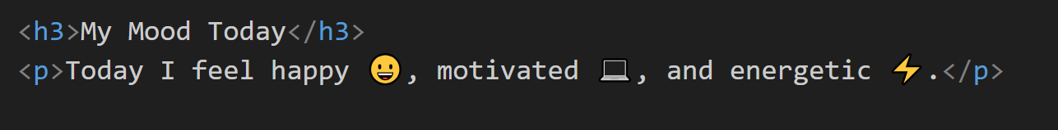

**Part 10 – Contact Form**

**Task:** Create a simple contact form with Name, Email, Favorite Color, and a Submit button.

Input:

Input:

**Summary**

In this project, I designed a simple personal webpage that includes sections such as introduction, hobbies, favorite websites, photo, button, weekly schedule, two-column layout, mood, and a contact form.  
The work process involved learning and using basic HTML tags such as <h1>, <p>, <ul>, <ol>, <table>, <img>, and <form>.  
This project helped me understand the structure of web pages and improve my practical skills in web design.

**GitHub Link**

[**https://github.com/aslamkhorami-byte**](https://github.com/aslamkhorami-byte)